|  |  |
| --- | --- |
| family | Untitled:private:var:folders:3b:v7klr2gx1rz8j57v2zgmcm900000gp:T:TemporaryItems:clipart-family-clip-art-pictures-family.jpg  **Capitalize:** Hold Shift button and tap letter.  **.**  Choose Period**.**  **Erase**: Put cursor behind letter and tap delete.  **Space**: Tap long spacebar.  **New line**: Tap Return key. |
| friends |  |
| teachers | Untitled:private:var:folders:3b:v7klr2gx1rz8j57v2zgmcm900000gp:T:TemporaryItems:BOY Teacher1.png |
| school | Untitled:private:var:folders:3b:v7klr2gx1rz8j57v2zgmcm900000gp:T:TemporaryItems:248b65d8-ba44-4478-8579-2fea34205aa3.jpeg |

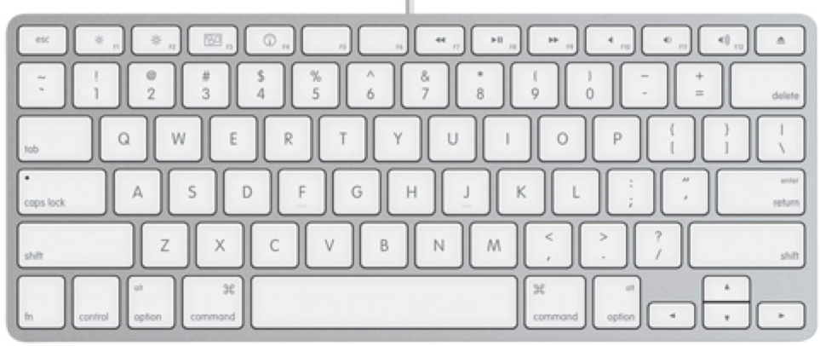

☺ I am thankful for my pet.

☺ I am thankful for

☺

☺

Name: